**REPORT**

**Q. 1) Find all the unique 'Wind Speed' values in the data.**

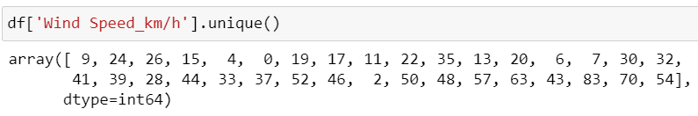

**EXPLANATION:**

In the Question find the unique values of this column “wind speed” then I use the function

Of “Unique”.

**Q. 2Find the number of times when the 'Weather is exactly Clear'.**

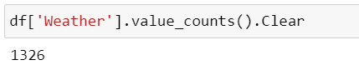

**EXPLANATION:**

In the Question find the no of times when “Weather is exactly clear” I use the function

“value_counts”.

**Q. 3) Find the number of times when the 'Wind Speed was exactly 4 km/h'.**

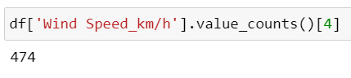

**EXPLANATION:**

In the Question find the no of times when “wind speed was exactly 4 Km/h” I use the

function “value_counts”.

**Q. 4) Find out all the Null Values in the data.**

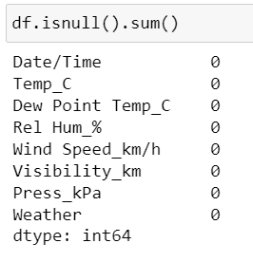

**EXPLANATION:**

In the question find null values of the Data set then I use the function” dataset .

Isnull().sum()” .

**Q. 5) Rename the column name 'Weather' of the data frame to 'Weather Condition'.**

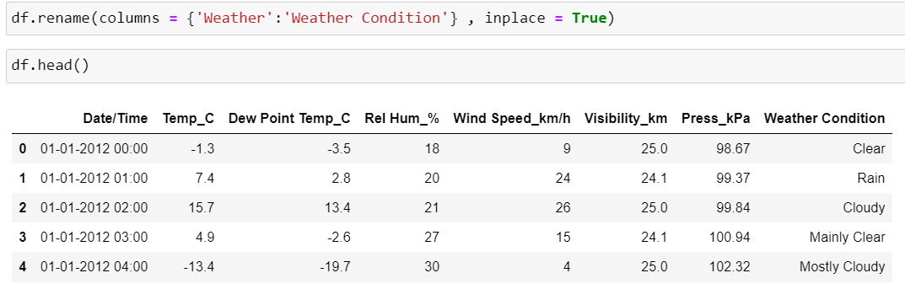

**EXPLANATION:**

In the question rename the column name “weather” to “weather condition” then I use the

function “rename” and I write the another condition “ inplace =True ” because that condition is

change the dataset is perminently.

**Q. 6) What is the mean 'Visibility'?**

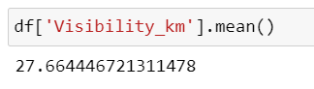

EXPLANATION:

In the Question find the mean value of this column “visibility” then I use the function Of

“mean”.

**Q. 7) What is the Standard Deviation of 'Pressure' in this data?**

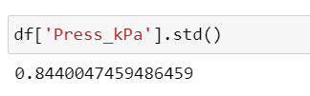

EXPLANATION:

In the Question find the Standard Deviation value of this column “Pressure” then I use

the function Of “std”.

**Q. 8) What is the Variance of 'Relative Humidity' in this data?**

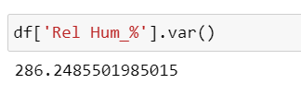

EXPLANATION:

In the Question find the “Variance” value of this column “Relative Humidity” then I use

the function Of “var”.

**Q. 9) Find all instances when 'Snow' was recorded.**

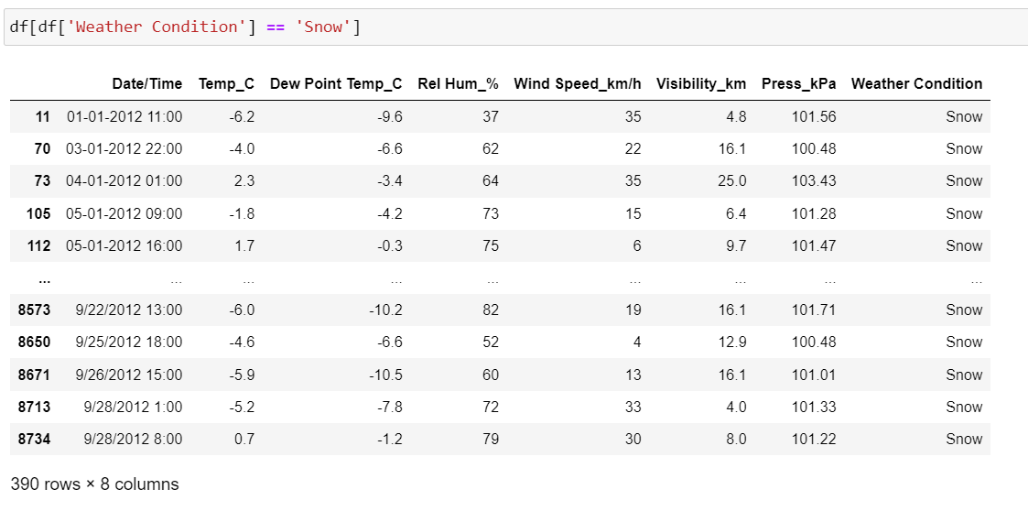

**EXPLANATION:**

In the question collect the information of “Snow” records then I use the condition of column

name == “snow”

**Q. 10) Find all instances when 'Wind Speed is above 24' and 'Visibility is 25'.**

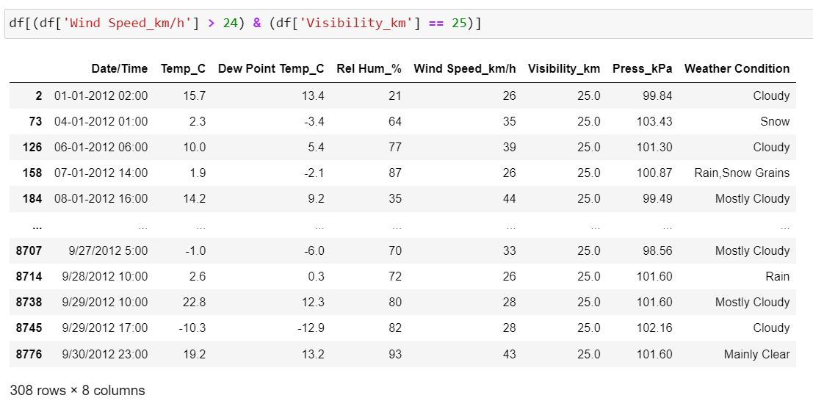

**EXPLANATION:**

In the question collect the information of “wind speed is above 40 ” and “visibility is 25” all

records then I write wind speed column name then write the condition > 40 and visibility ==25.

**Q. 11) What is the Mean value of each column against each 'Weather Condition?**

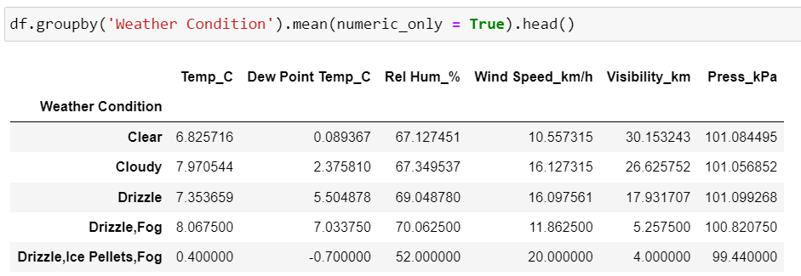

**EXPLANATION:**

In the question find the mean value of total set use the column name of “weather condition”

That’s why group by the column name and we find mean value only numerical columns then I

write condition mean(numeric_only=True)

**Q. 12) What is the Minimum & Maximum value of each column against each 'Weather Condition?**

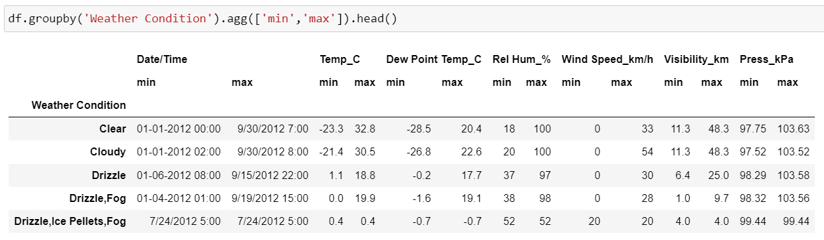

**EXPLANATION:**

In the question find the MINIMUM and MAXIMUM value of total set use the column name of

“weather condition” I use the function agg([“min”,”max”]).

**Q. 13) Show all the Records where Weather Condition is Fog.**

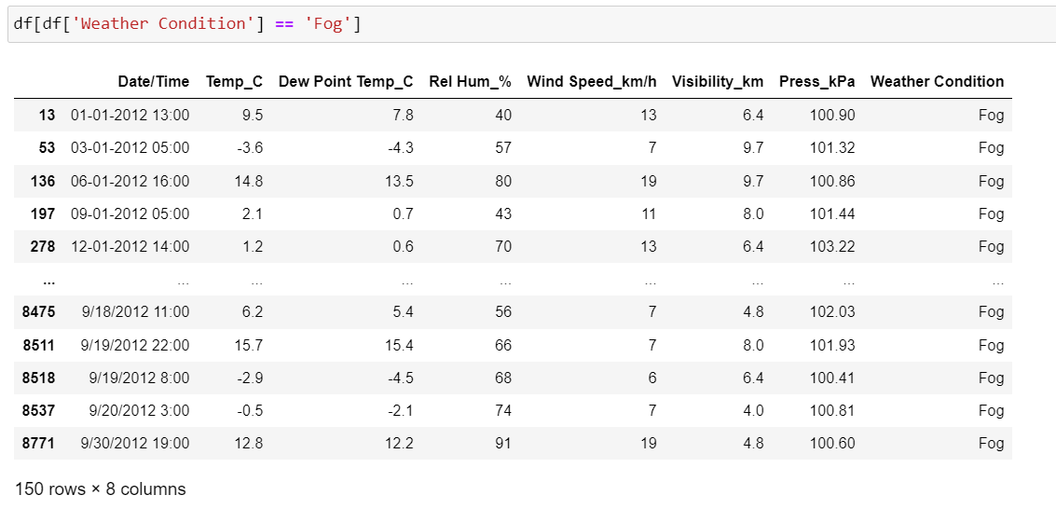

**EXPLANATION:**

In the question find the all records of when “weather condition is fog “ then I write the

condition of column name == “Fog”

**Q. 14) Find all instances when 'Weather is Clear' or 'Visibility is above 40'.**

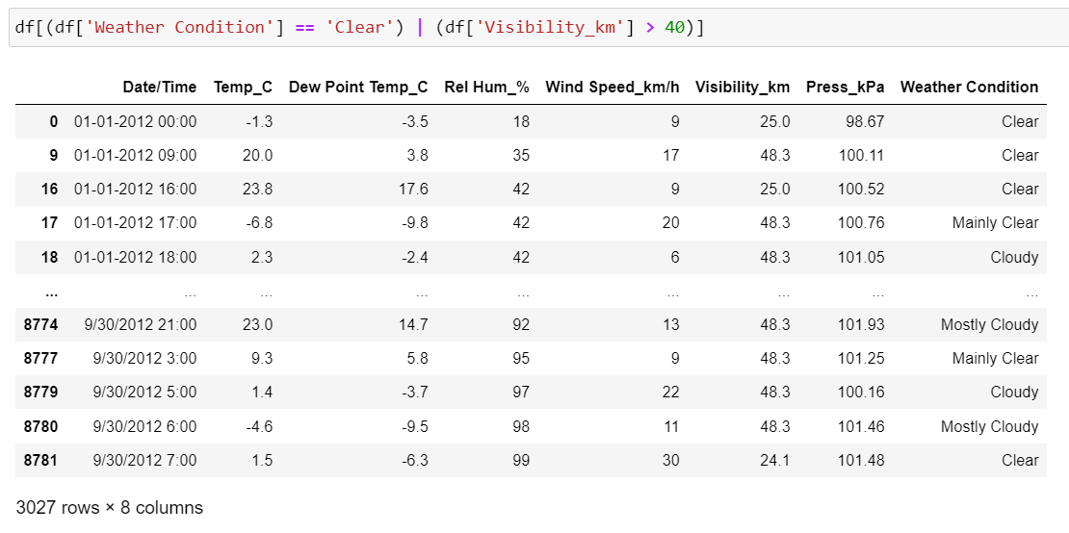

**EXPLANATION:**

In the question collect the information of “weather condition is clear ” or “visibility is above

40” all records then I write the condition weather condition == clear 40 or visibility >40.

**Q. 15) Find all instances when:**

**A. 'Weather is Clear' and 'Relative Humidity is greater than 50'**

**or**

**B. 'Visibility is above 40'.**

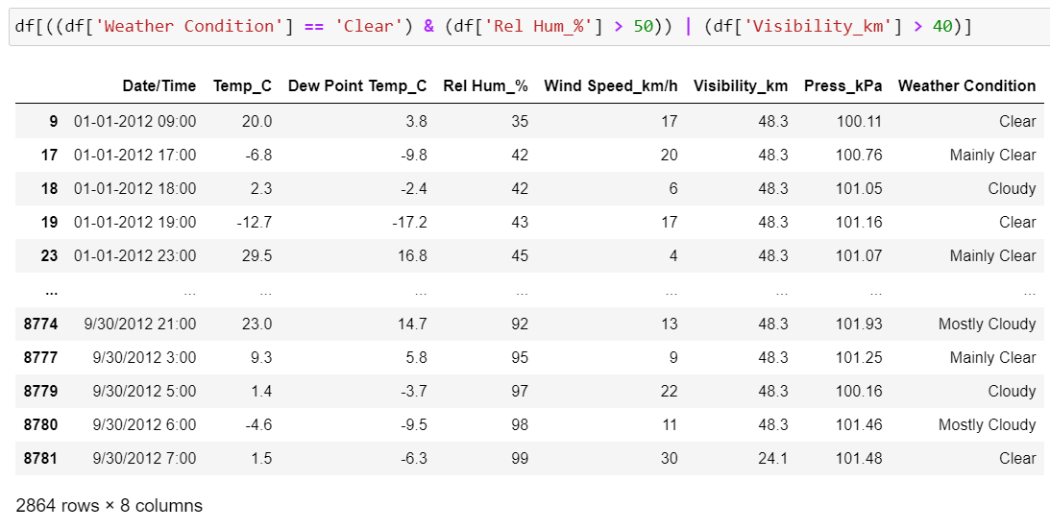

**EXPLANATION:**

In the question collect the information of “weather condition is clear ” and “Relative

Humidity is greather than 50 or “visibility is above 40” all records then I write the condition

weather condition == clear 40 and Relative Humidity >50 or visibility >40.